IT24100059 – Dharmadasa O.A.P.S.

PS Labsheet 9

1.

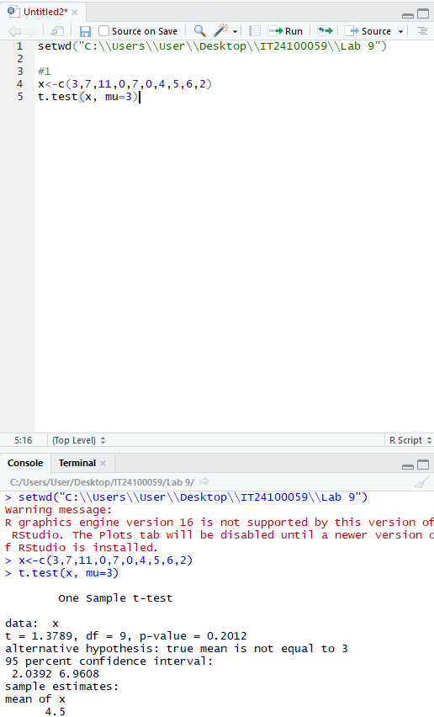

2.

3.

Question



